Name : Abdul Rehman Section :B

Course : AI&ES Roll No : CT-22052  
---------------------------------------------------------------------------------------------------------------------  
 **Lab # 5**

**Q1: Define the term object detection. How is it applied in AI-based applications?**

● Object detection is a computer vision technique used to locate and recognize objects within images or videos. It is widely used in AI applications such as surveillance, autonomous vehicles, and facial authentication. This technique enables machines to interpret visual data and make better decisions.

**Q2: What distinguishes image classification from object detection, and what are the key implementation differences?**

● Image Classification:

○ Assigns a single label to an entire image.

○ Utilizes deep learning models like ResNet or VGG.

○ Produces a single output class per image.

○ Requires lower computational power.

○ Example: Determines if an image contains a cat or a dog.

● Object Detection:

○ Detects and locates multiple objects in an image.

○ Uses techniques like YOLO, SSD, or Faster R-CNN.

○ Outputs class labels along with bounding box coordinates.

○ More computationally intensive due to additional processing.

○ Example: Identifies the exact position of a cat or dog within an image.

**Q3: List the sequential steps of the Viola-Jones Object Detection Algorithm.**

● Convert the input image to grayscale.

● Compute an integral image for fast feature extraction.

● Extract Haar-like features from the image.

● Utilize AdaBoost to select the most relevant features.

● Apply a cascading classifier to efficiently detect objects.

**Q4: What is an integral image, and how is it useful in object detection?**

● An integral image is a data representation that speeds up pixel sum calculations over rectangular regions. It minimizes redundant operations, making feature extraction in object detection algorithms more efficient.

**Q5: Explain the concepts of Weak and Strong Classifiers and describe the parameters of the following equation.**

● Weak Classifier:

○ A classifier that performs slightly better than random guessing.

● Strong Classifier:

○ A combination of multiple weak classifiers that collectively provide higher accuracy.

● Example: The AdaBoost algorithm, used in the Viola-Jones framework, merges several weak classifiers into a single strong classifier to enhance performance.

**Q6: Discuss the functionality of various Python libraries used in object detection.**

● OpenCV: Offers pre-trained models for face and object detection using Haar cascades.

● TensorFlow/Keras: Implements deep learning-based object detection models like SSD and Faster R-CNN.

● PyTorch: Provides frameworks for training modern object detection models, such as YOLO and Mask R-CNN.

● Scikit-learn: Assists in training machine learning-based classifiers for object recognition.

**Q7: Run object detection on 10 different images, evaluate accuracy, and display the results.**

**CODE:**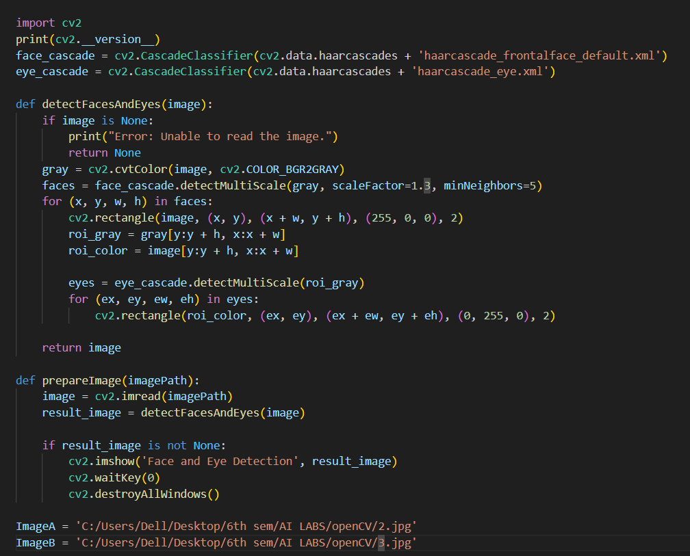

**Test images:** **OUTPUT results:**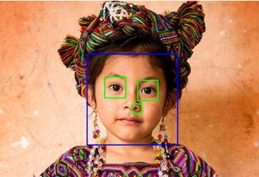Here this is some buggy behavior as it is also detecting nostrils as Eye!  
  
  
  
  
No detection

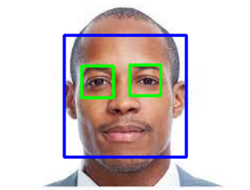Perfectly detected  
  
=====================================================================